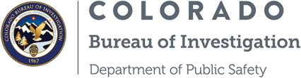
Identification Unit
690 Kipling Street, Suite 4000 Denver, CO 80215
303-239-4208
NOTICE TO APPLICANTS
As an applicant for a position requiring fingerprints to be submitted to the Colorado Bureau of Investigation and the Federal Bureau of Investigation, YOUR FINGERPRINTS WILL BE SUBMITTED TO THESE AGENCIES TO CHECK STATE AND FBI RECORDS.
Discrepancies on your Colorado record can be challenged and corrected by contacting the Colorado Bureau of Investigation at 690 Kipling St., Suite 3000, Denver, CO 80215, or by calling the Identification Unit at (303) 239-4208 Additional information is available from CBl's website at www.colorado.gov/cbi.
Discrepancies on records from the FBI or relating to another state can be challenged through the FBI. Information, including that listed below, can be found at their website at
www .fbi.gov.
The U.S. Department of Justice Order 556-73 establishes rules and regulations for the subject of an FBI Identification Record to obtain a copy of his or her own record for review. The FBl's Criminal Justice Information Services (CJlS) Division processes these requests.
Who May Request a Copy of a Record (or Proof That a Record Does Not Exist)? Only you can request a copy of your own Identification Record.
How to Request a Copy of Your Record
The FBI offers two methods for requesting your FBI Identification Record or proof that a record does not exist.
Option 1: Submit your request directly to the FBI.
Option 2: Submit to an FBI-a pproved Channeler, which is a private business that has contracted with the FBI to receive the fingerprint submission and relevant data, collect the associated fee(s), electronically forward the fingerprint submission with the necessary information to the FBICJIS Division for a national criminal history record check, and receive the
electronic record check result for dissemination to the individual. Contact each Channeler for processing times.
AGENCY INSTRUCTIONS: To comply with federal law, provide a copy of this document to each applicant fingerprinted.
700 Kipling Street Suite 1000, Lakewood, CO 80215 cdpsweb.state.co.us
John W. Hickenlooper, Governor | Stan Hilkey, Executive Director
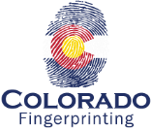
Approved Vendor for
Colorado Bureau of Investigation

