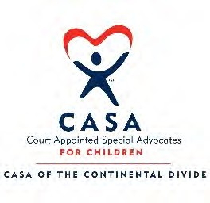
CASA of the Continental Divide Chip in for Kids

2021 Golf Scramble Sponsorship

CASACD is celebrating 22 years of advocacy and support for children in Clear Creek, Eagle, Lake, and Summit Counties. Your support makes our work possible! Sponsors will be recognized in golf scramble marketing materials including: Posters; Website; Registration Materials; Signs at the event; Social Media; and unique recognition at the meal/beverage/contest that you select to sponsor.

Food & Beverage:  Dinner (2) | $2,500 | $
1st Lunch Station (2) | $1,200 | $
2nd Lunch Station (2) | $1,200 | $
Bloody Mary/John Daly Bar | $600.00 | $
Beverage Cart | $500.00 | $
Beer Coolers at holes (5) | $1,000 or $200 each | $
Contests: (Sponsorship could supply prize rather than cash)
Marsh-Mellow Longest Drive | $200 to purchase prizes | $
1st place team | $600 | $
2nd place team | $400 | $
3rd place team | $200 | $
Hole Sponsor (18) | $200 per hole | $
19TH Hole Bar (2) | $1,200 (each) | $

General Sponsorship:
Pledge Restrictions

Silent Auction Donation:
Item(s) Item(s) Item(s)

$

Value $ Value $ Value $

Contact Information
Organization

Contact Name Address
Phone

email

For questions about sponsorship opportunities please contact Lisa Reeder lisa.reeder@mtncasa.org

